2.0 Contents

2.1 Design solution (Use Case Diagram and Class Diagram)

2.1.1 Use Case Diagram for Customer
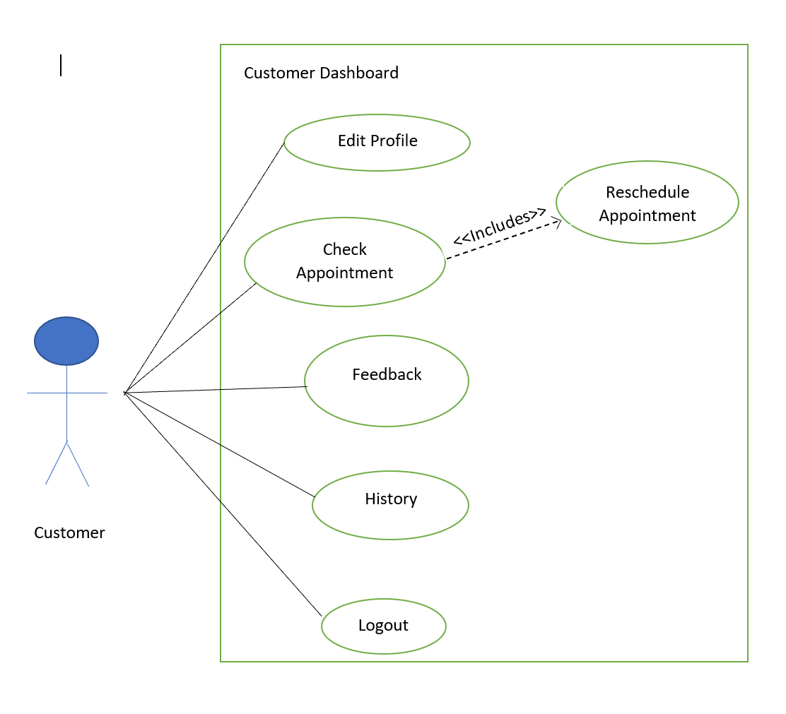

2.1.5 Class Diagram for Customer (Ehtisham Mehmood Sadeq TP081623)
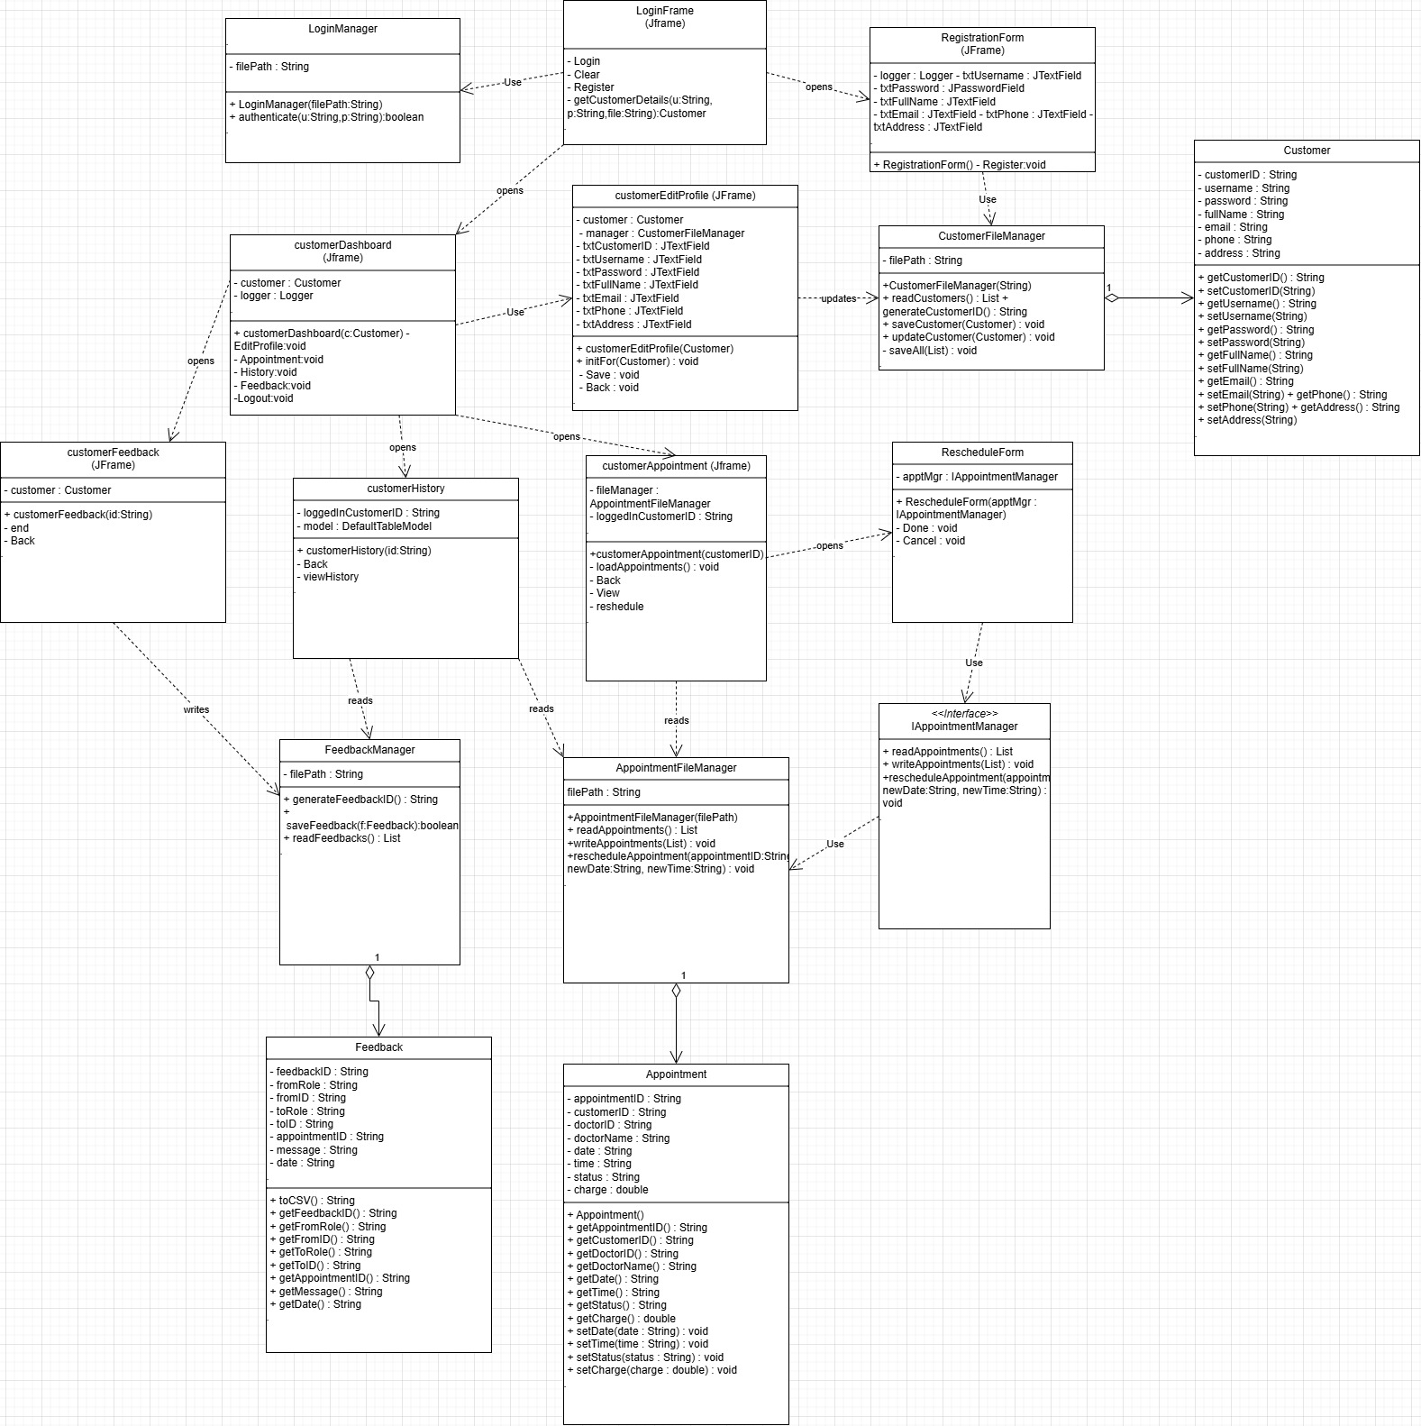

2.2 Screenshots of output of the program with appropriate explanations

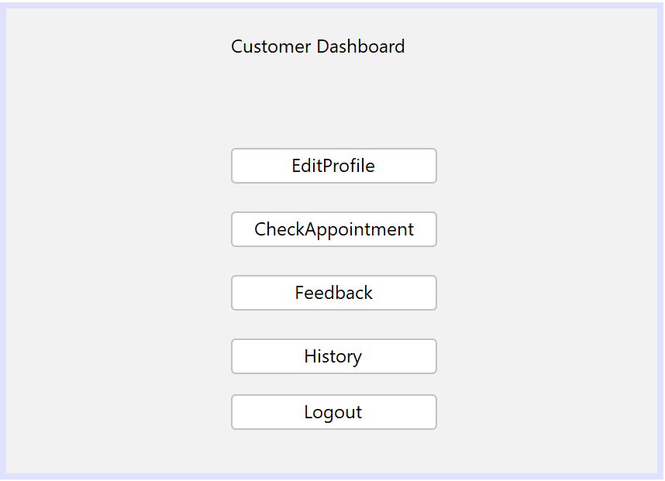
Figure 1.0 Customer Dashboard
This is the dashboard for the customer. here, the customer can check upcoming appointments, view history, provide comments, and edit their profile. Each button opens the Jframe Form window.
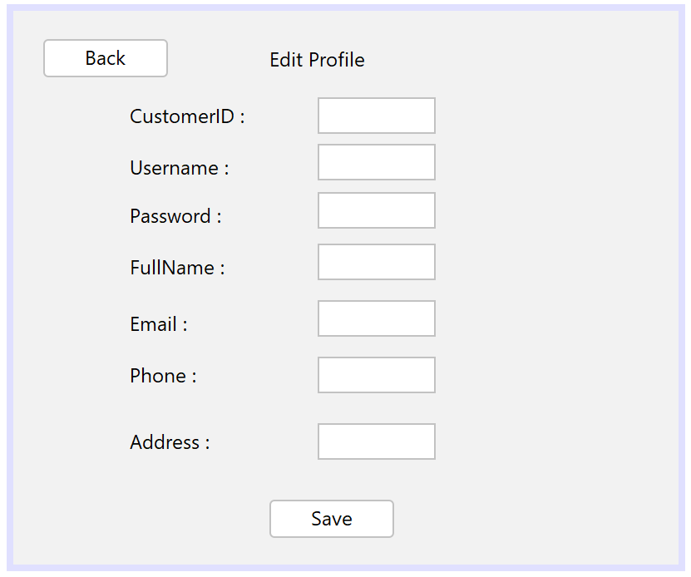
Figure 1.1 Customer Edit Profile
Here customers can update their profile information. The updated details overwrite the record in Customer.txt, ensuring that the latest information is stored.
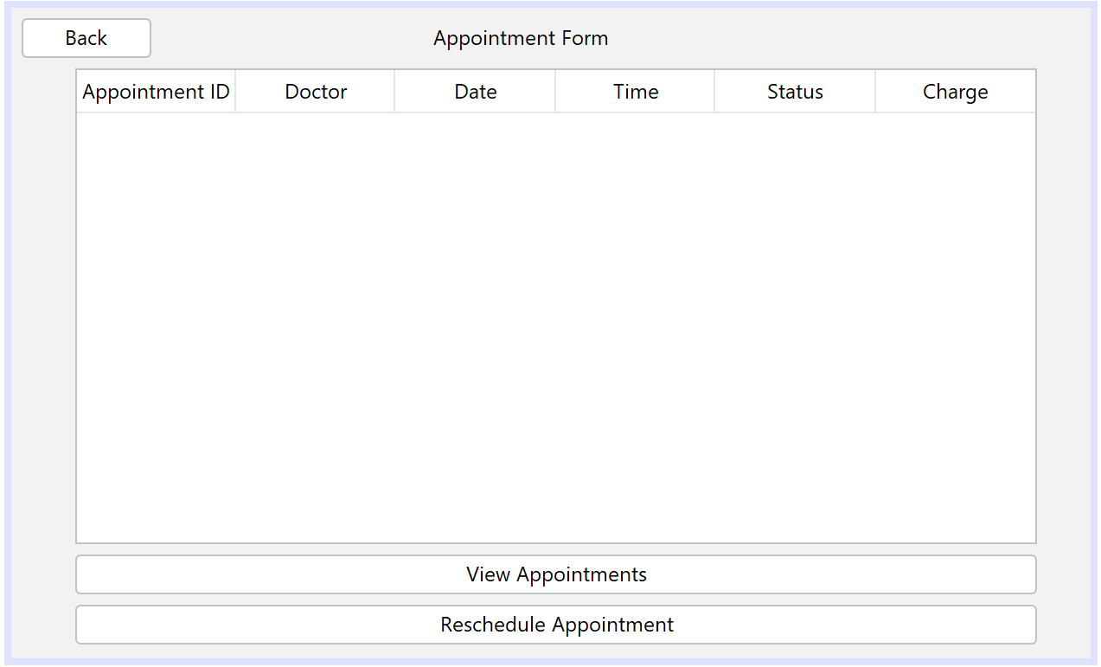
Figure 1.2 Customer Check Appointment
This customer Appointment Forms displays all upcoming appointments of the customer by reading from Appointment.txt where status is CONFIRMED. Customers can only view appointments that is confirmed.
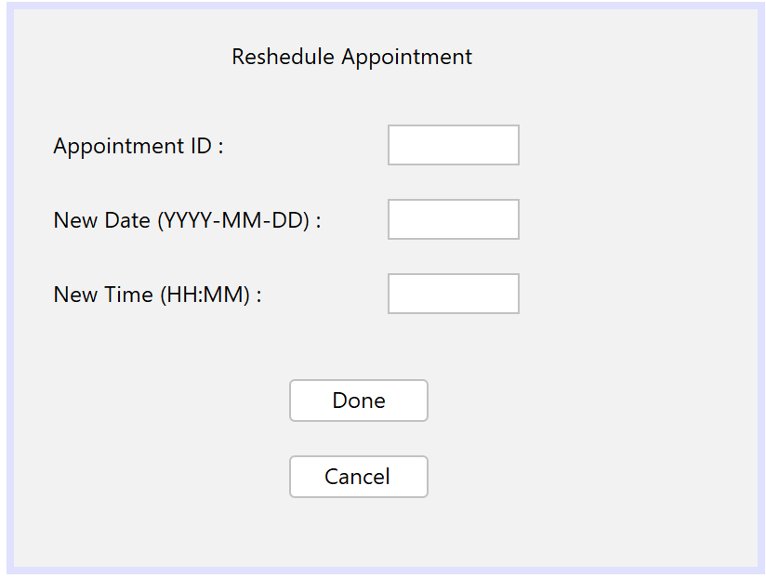
Figure 1.3 Customer Reschedule Appointment
Customers can reschedule their Appointment. The updated details overwrite the record in Appointment.txt, and the status is change to pending.
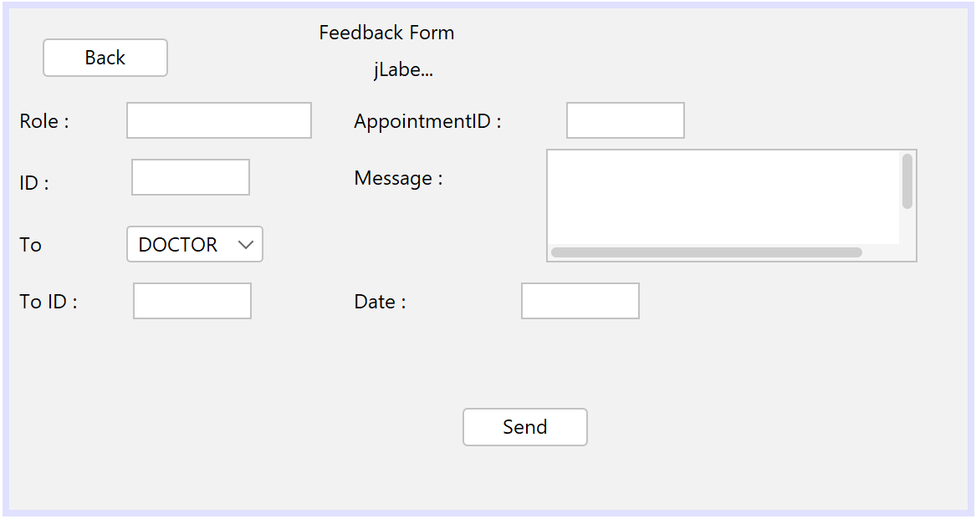
Figure 1.4 Customer FeedbackForm
Customers can provide comments to doctors or staff. Once submitted, the comment is stored in feedback.txt with fields like FromRole, ToRole, AppointmentID and Message. This ensures communication between customers and clinic staff/doctors.
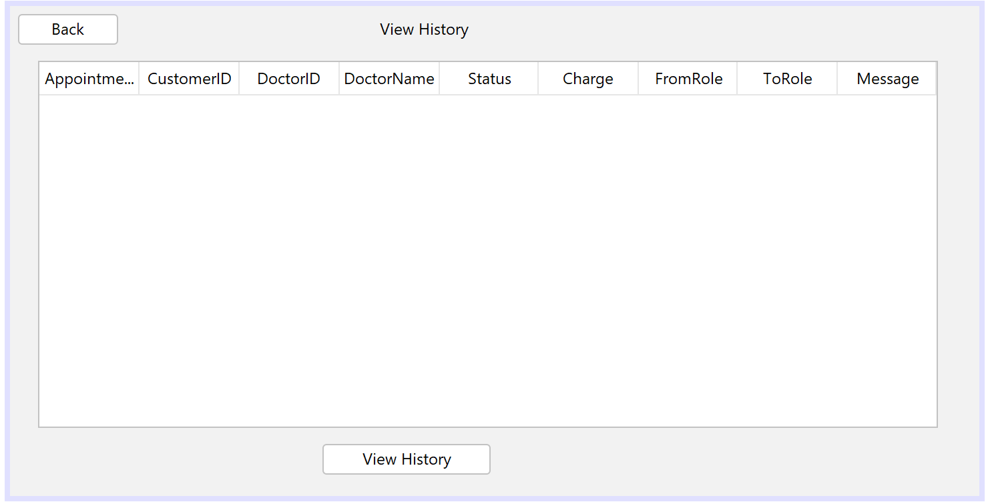
Figure 1.5 Customer View History Form
The history Form shows completed or cancelled appointments along with charges, comments made by the customer, and feedback received from doctors and staff. Data is combined from appointments.txt and feedback.txt.

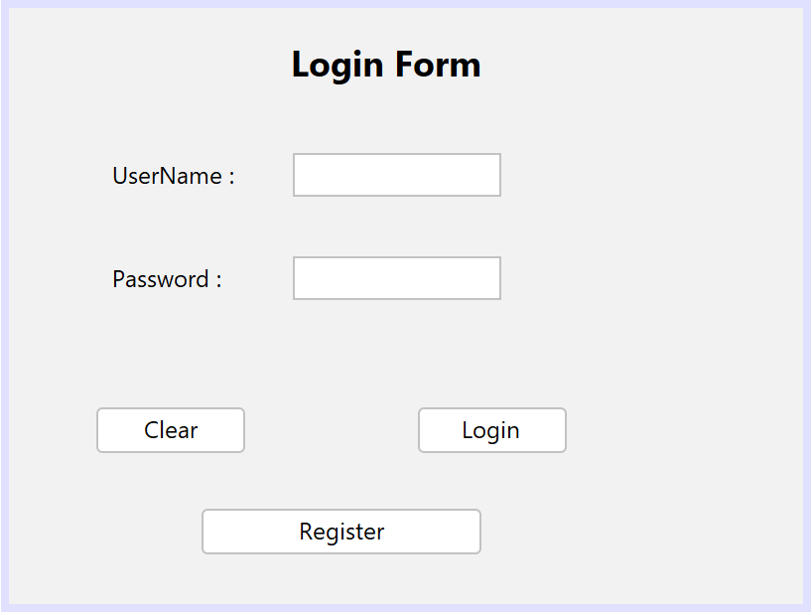
Figure 1.6 Login Form
The login form validates credentials in customer.txt. If successful, the system opens the customer dashboard. This ensures only registered User can access the system.
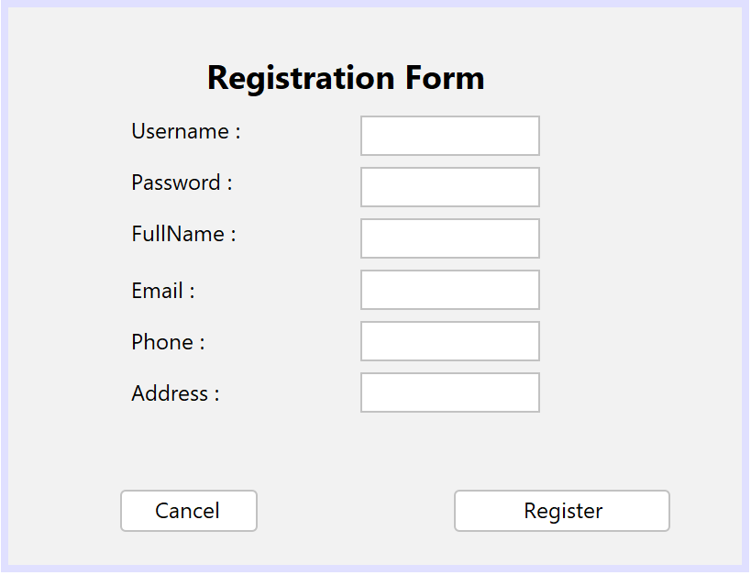
Figure 1.7 Registration Form
This form allows a new customer to register in the system. The details entered are validated and then stored into the customer.txt. Once registered, the customer can log in using their username and password.

2.4 Additional feature
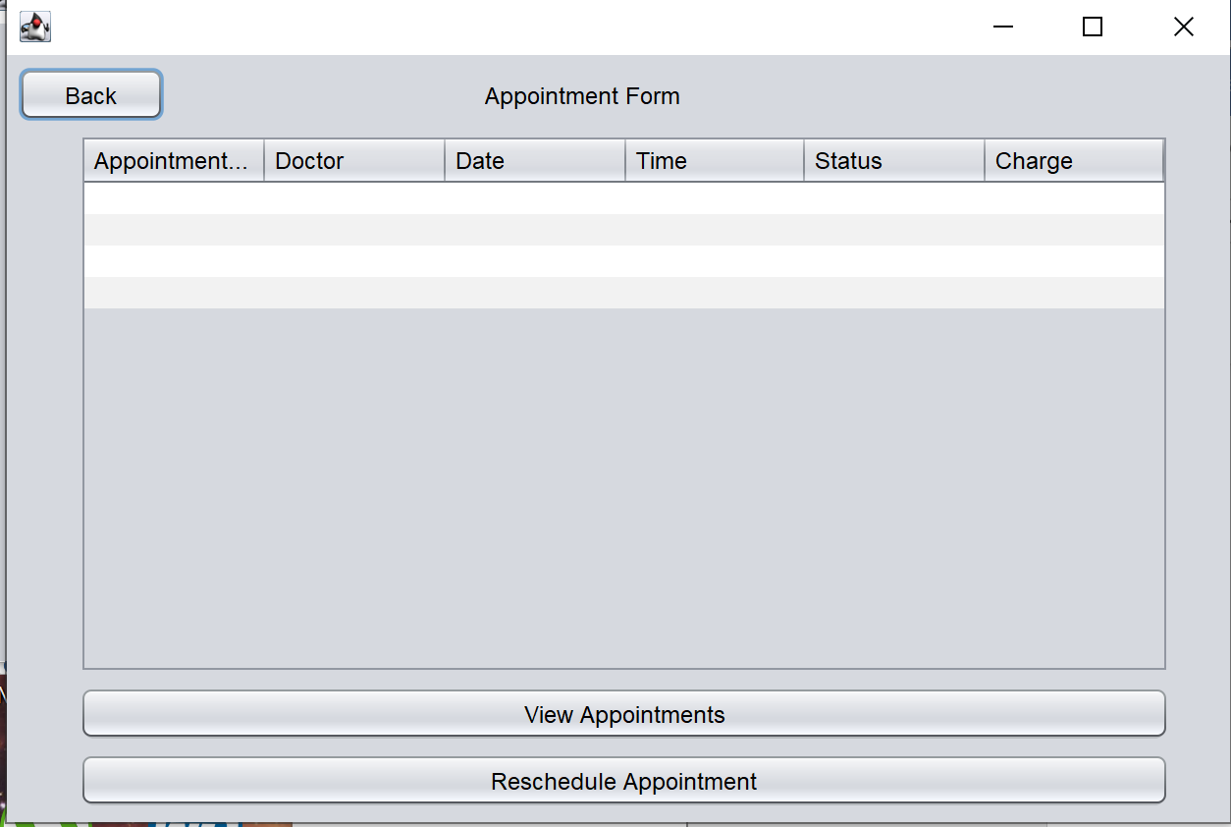
8.0 Appointment Form
This is the appointment form and inside the appointment form there is reschedule appointment button that open the reschedule appointment form and that’s the extra feature for the customer user
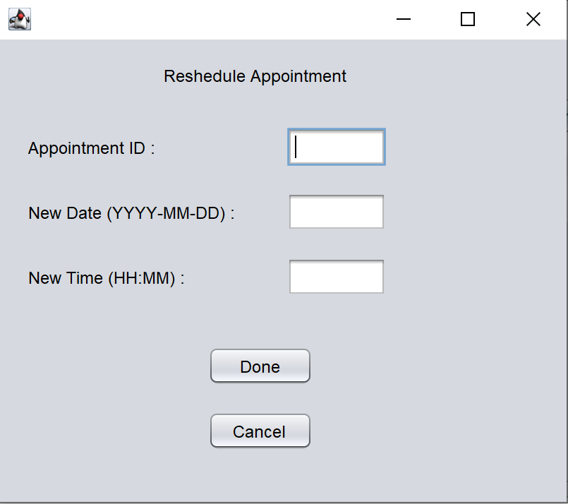
8.1 Reschedule Appointment
This is the reschedule Appointment page here customer can reschedule there appointment, customer just have to add the appointment ID and the new date that customer wants to shift there appointment after pressing done Jbutton the appointment.txt file is updated and the status is change to pending so that the staff can update the pending status to confirm

